Master Services Agreement (MSA) – Data Research Services
Guidance Notes
The MSA has been developed by Health Data Research UK for use by Health Data Research Hubs.
Overview
- The MSA is a framework under which individual statements of work (SOWs) can be called off. Each SOW forms a separate contract governed by (i) the General Conditions set out in Parts B and C of the MSA, (ii) the MSA Special Conditions, and (iii) the SOW Specific Terms.
- In order to use the MSA template:
  - the parties first need to complete the MSA Special Conditions; and then
  - when entering into a SOW under the MSA, the parties need to complete the SOW Specific Terms.
- The MSA template structure avoids the need to renegotiate the General Conditions on a case by case basis - such terms are simply disapplied or amended by the exercise of completing the MSA Special Conditions or the SOW Specific Terms if / as relevant.
Structure of the arrangement
As the Hubs are not legal entities, the MSA template provides for the MSA to be between the lead organisation of the Hub and the relevant customer. The lead organisation may need to enter into further contracts with other relevant Hub members or data custodians (as applicable) in order to flow-down the MSA obligations as required (e.g. if not all services are to be provided by the lead organisation) to the extent this is not already covered in an existing collaboration agreement.
This structure is summarised in the following diagram:
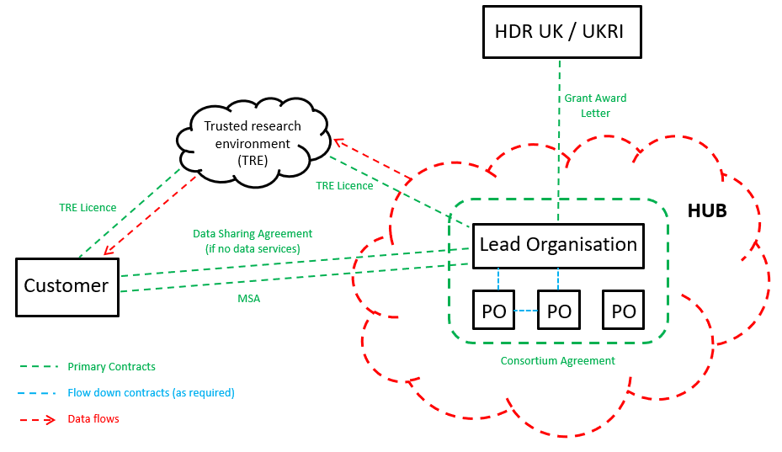
The MSA template can be used where the Hub is providing data services in respect of target datasets owned or licensed by Hub consortium members.
If the customer is only being provided with access to target datasets (i.e. without any associated data services), then an appropriate data sharing agreement should be used instead of the MSA template.

Structure of the MSA template
The General Conditions of the MSA template are split into three parts:
- Part A: sets out provisions applicable solely to the MSA.
- Part B: sets out provisions applicable solely to each SOW.
- Part C: sets out provisions applicable to both the MSA and each SOW.
How to use the MSA template
- To enter into an MSA
  - Fill out the required information highlighted in yellow in the MSA Special Conditions. Further details are given as to the required information in Annex A to these Guidance Notes.
  - The MSA Special Conditions are to be used to incorporate any additional terms and/or to amend the General Conditions. Examples of additional terms that may be relevant on a case by case basis are included in Annex C to these Guidance Notes.
- To enter into a SOW
  - Fill out the required information highlighted in yellow in the SOW Specific Terms. Further details are given as to the required information in Annex B to these Guidance Notes.
  - Select as required the relevant colour-coded provisions dependent on the nature of the arrangement.
    - SCENARIO A: these provisions should be selected if the customer does not have access to the Target Datasets and is not considered to be a data controller in respect of the Target Dataset
    - SCENARIO B: these provisions should be selected if the customer does not have access to the Target Datasets and is considered to be a data controller in respect of the Target Dataset
    - SCENARIO C: these provisions should be selected if the customer does have access to the Target Datasets and is a data controller in respect of the Target Datasets
To determine the relevant scenario, it is important to understand what qualifies as a “controller” under the GDPR/Data Protection Act. Note in particular that a customer can be a controller even though it does not have access to the personal data if that customer can influence how and why the data is being used. More guidance on this topic can be found here:
https://ico.org.uk/for-organisations/guide-to-data-protection/guide-to-the-general-data-protection-regulation-gdpr/controllers-and-processors/
If the customer will have access to the Target Datasets but it is unclear whether such datasets constitute personal data, select Scenario C (as the terms in Appendix 1 only apply to the extent that such Target Datasets (or part thereof) constitute personal data).
  - The SOW Special Terms are to be used to incorporate any additional terms and/or to amend the General Conditions specific to that SOW. Examples of additional terms that may be relevant on a case by case basis are included in Annex C to these Guidance Notes.

Updating the MSA template to reflect the relevant commercial model
The template MSA can be used for arrangements based on commercial models taken from the Hub commercial framework, as set out below:
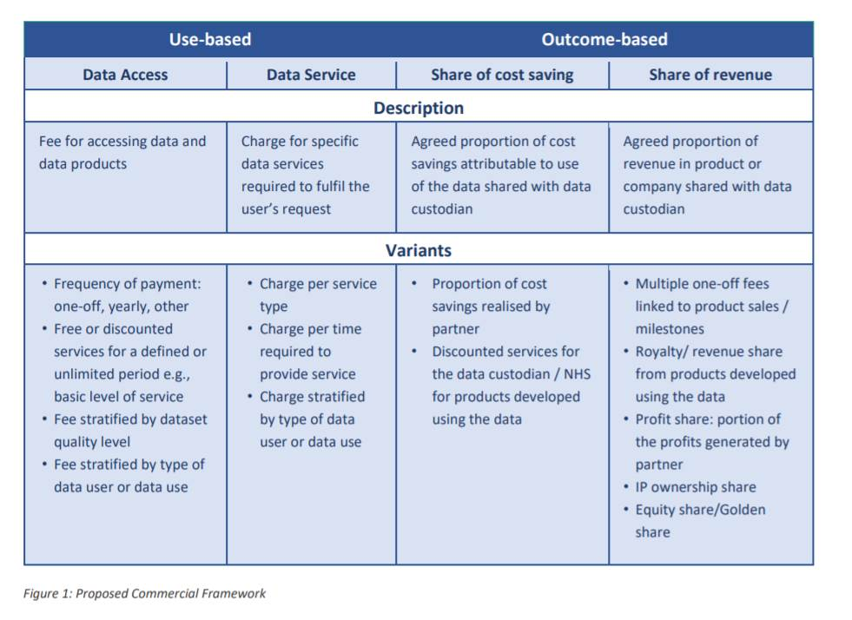
It is possible for multiple elements of the commercial framework to be applied as part of an arrangement. In each instance, the specific payment terms should be set out in the Charges section of the SOW. Some limited updates may also be required to the MSA template on a case-by-case basis to reflect the chosen commercial model(s).
Taking each commercial model in turn:
- Data Access
  - The fee relating to data access should be detailed in the Charges section of the SOW, including details about how the fee will be charged – such as the frequency for payment of the fee, whether the fee is on a per user or per organisation basis (and if on a per user basis the cost of an additional user), etc.
  - No specific changes are needed to the remainder of the template MSA to reflect this model. However, consider whether it is appropriate to include clauses 11.12 to 11.15 (which relate to the payment of royalties upon commercialisation) in the context of the arrangement.
- Data Service
  - The fee relating to the data services should be detailed in the Charges section of the SOW, including details about how the fee will be charged – such as the frequency for payment of the fee, how the fee is calculated (e.g. fixed fee or on a time and materials basis), etc.
  - As above, no specific changes are needed to the remainder of the template MSA to reflect this model. However, consider whether it is appropriate to include clauses 11.12 to 11.15 (which relate to the payment of royalties upon commercialisation) in the context of the arrangement.
- Share of cost saving
  - The details relating to the share of cost saving should be detailed in the Charges section of the SOW. This will need to include detail of:
    - the mechanism that will be used to calculate the cost savings; and
    - the manner and frequency in which these costs savings should be paid to the Hub.
  - Some additional terms may need to be included in the SOW to reflect this mechanism, including (for example), some detailed audit rights for the Hub so that it can verify the amounts paid under the mechanism.
  - Some limited updates may also be needed to the MSA template to reflect this model, including clause 10. Consider also whether it is appropriate to include clauses 11.12 to 11.15 (which relate to the payment of royalties upon commercialisation) in the context of the arrangement. If discounted services or licences are to be provided by the customer (whether to the Hub and/or the wider NHS), consider whether any updates are required to clauses 11.6, 11.7, 11.10 and 11.11.
- Share of revenue
  - There are multiple variations of this commercial model. If the selected model is for an agreed proportion of revenue in products to be shared with the Hub:
    - Clauses 11.12 to 11.15 of the template MSA set out the process by which royalty payments shall be calculated and paid in respect of any Deliverables or Derivative Works that are commercialised by the customer. The agreed proportion and payment frequency should be detailed in the Royalty Payment section of the SOW.
    - The template MSA provides that royalty payments are exclusive of VAT. Consider whether any other taxes or withholding payments would be applicable and need to be covered in the agreement (e.g. withholding taxes on cross-border payments).
  - If the mechanism for charging royalty payments is not known at contract signature, the alternative clause in Annex C relating to 'Intellectual Property Rights – Commercialisation' could be used. This alternative clause restricts commercialisation by the customer without the consent of the Hub and provides more flexibility for the parties to agree royalty payments once the Deliverables and Derivative Works are known.
  - Clauses 11.12 to 11.15 can also be used as the basis for many of the variations to this commercial model, though this will not be appropriate for all of them (such as IP ownership share). Updates will need to be considered on a case-by-case basis.
  - HDR UK would be happy to hear from you if you are using an alternative model and may be able to provide further guidance if required.

Indicative matters to consider on a case by case basis
- Consider whether the template IPR provisions reflect the commercial arrangement
As drafted, clause 11 of the MSA template grants the customer ownership of IPRs in Deliverables. Consider whether this is the desired arrangement or whether the alternative IPR provisions in Annex C to these Guidance Notes would be more appropriate.
- Consider whether any third-party software / IP licences are required by either party
If so, include appropriate terms (most likely as SOW Specific Terms) regarding responsibilities for obtaining any such licences. For example, this might include a licence for the customer to access the Trusted Research Environment where such licence is being provided or procured by the lead organisation of the Hub.
- Consider the potential application of TUPE on commencement / termination or expiry of a relevant SOW
The General Conditions assume that TUPE will not apply. Consider on a case by case basis whether TUPE will apply.
- Consider other potential consequences of termination or expiry of a relevant SOW
Consider for example whether there would be a need for:
  - exit assistance;
  - the retention of the other party's confidential information; and/or
  - the retention of a copy of the Target Datasets, to be made available to the customer upon request if required for regulatory purposes.
- Consider the liability positions under the MSA and SOW
Consider for example whether to include any indemnities in the context of the services being provided (e.g. in relation to breach of confidentiality by either party or in relation to IPR infringement claims). The template MSA includes a mutual data protection indemnity at clause 14.5 with a mechanism for a cap to be placed on recovery of losses under such indemnity – consider whether this is appropriate and/or whether any limitations on recovery may be appropriate.
- Consider whether it would be helpful to include dispute resolution clauses
Consider for example whether it would be helpful to include a dispute escalation process or resolution procedure (e.g. arbitration).
- If Scenarios B or C are selected, consider whether the template data protection provisions in Appendix 1 reflect the arrangement regarding data
Consider for example the following:
  - whether the customer may need to enter into a joint controllership arrangement with a third party data custodian in order for such parties to comply with their GDPR Article 26 obligations;
  - whether there is a need to include any restrictions on data use / sharing or other provisions relating to the scope of an existing data subject consent or section. 251 approval; and/or
  - whether the data use / sharing is conditional on one or both parties obtaining additional consents, ethics reviews or section. 251 approvals.

Annex A – Completing the MSA Special Conditions
Guidance notes are included in red.
MSA Special Conditions
Party details
Supplier | [insert company name], a company incorporated in [insert country] (company number [insert registration number]), with its registered address at [insert address]  These are the details of the contracting party on behalf of the Hub – i.e. the lead organisation.
Customer | [insert company name], a company incorporated in [insert country] (company number [insert registration number]), with its registered address at [insert address]  These are the details of the Customer receiving the services.
Hub | [insert (e.g. DATA-CAN)] Health Data Research Hub  This is the name of the relevant Hub.
Supplier Notice Details | For the attention of: [insert name/position]  Address: [insert address]  Email: [insert email address]  These are the contact details for the Supplier where notices under the MSA will be sent – see clause 15.11 of the MSA.
Customer Notice Details | For the attention of: [insert name/position]  Address: [insert address]  Email: [insert email address]  These are the contact details for the Customer where notices under the MSA will be sent – see clause 15.11 of the MSA.
Commercial terms
Commencement Date | [insert date]  This is the date on which the MSA will come into force.
Term | A period of [insert agreed time period] from the Commencement Date  This is the duration of the MSA.  Note that the duration of a SOW may continue beyond the term of the MSA.
Supplier MSA Liability Cap | The greater of:  - [insert (£insert)]; and  - a sum equal to [insert (insert%)] of the total Charges paid and/or payable under this Agreement and all SOWs.  This is the aggregate liability cap that applies in relation to the Supplier's liabilities arising pursuant to the MSA and all SOWs - see clause 14.2(a) of the MSA.
Customer MSA Liability Cap | [insert details of Customer's liability cap under the Agreement]  This is the aggregate liability cap that applies in relation to the Customer's liabilities arising pursuant to the MSA and all SOWs - see clause 14.3(a) of the MSA.
Additional terms (if any)
[insert details of any additional terms that apply (if any) - see the MSA Guidance Notes for example clauses]

Annex B – Completing the SOW Specific Terms
Guidance notes are included in red.
SOW Specific Terms
Party details
Supplier |  | [insert company name], a company incorporated in [insert country] (company number [insert registration number]), with its registered address at [insert address]  These are the details of the contracting party on behalf of the Hub – i.e. the lead organisation. This should be the same contracting entity as in the MSA.
Customer |  | [insert company name], a company incorporated in [insert country] (company number [insert registration number]), with its registered address at [insert address]  These are the details of the Customer contracting party. This should be the same contracting entity as in the MSA.
Supplier Notice Details |  | For the attention of: [insert name/position]  Address: [insert address]  Email: [insert email address]  These are the contact details for the Supplier where notices under the SOW will be sent – see clause 15.11 of the MSA.
Customer Notice Details |  | For the attention of: [insert name/position]  Address: [insert address]  Email: [insert email address]  These are the contact details for the Customer where notices under the SOW will be sent – see clause 15.11 of the MSA.
Master Services Agreement |  | As between the parties dated [insert date]  This is the stated 'Commencement Date' of the MSA.
Commercial terms
SOW Commencement Date |  | [insert date]  This is the date on which the SOW will come into force.
SOW Term |  | From the SOW Commencement Date until [expiry of [insert time period] / completion of the Services]  This is the duration of the SOW.  Note that the duration of a SOW may continue beyond the term of the MSA.
Derivative Work Licence Date |  | [insert time period / Immediately] following creation of the Derivative Work  This is the date on which a licence is granted to the Supplier to use Derivative Works developed by the Customer in accordance with clause 11.11.
Royalty Payment |  | A [insert frequency e.g. monthly / quarterly / annually] royalty equal to [insert percentage (x)%] of the Net Sales Price of each Deliverable or Derivative Work that is sold or otherwise supplied by or on behalf of Customer to any person.  This sets out (i) the frequency for payment of Royalty Payments, and (ii) how the Royalty Payment will be calculated as a percentage of the Net Sale Price of the relevant Deliverable or Derivative Work.  The Royalty Payment shall be paid within thirty (30) calendar days of [insert frequency for payment e.g. the end of each month], based on the Deliverables or Derivative Works sold or otherwise supplied by or on behalf of Customer within that period.  This should clearly specify the frequency for payment of Royalty Payments.
Charges |  | [insert details of (i) the Charges payable for the Services (inclusive of VAT), (ii) details of any expenses other expenses that may also be payable; and (ii) invoicing requirements (including when Supplier is entitled to raise an invoice]  These are the charges that will be payable by the Customer under the SOW in accordance with clause 10 of the MSA.
Supplier SOW Liability Cap |  | The greater of:  - [insert (£insert)]; and  - a sum equal to [insert (insert%)] of the total Charges paid and/or payable under this SOW.  This is the aggregate liability cap that applies in relation to the Supplier's liabilities arising pursuant to the SOW - see clause 14.2(b) of the MSA.
Supplier SOW Data Protection Liability Cap |  | [insert details of Supplier's liability cap under the data protection indemnity relevant to this SOW – insert value]  This is the aggregate liability cap that applies in relation to the Supplier's liabilities arising under the data protection indemnity (at clause 14.5) of the MSA – see clause 14.2(c) of the MSA.  Note that this cap falls outside the Supplier MSA Liability Cap.
Customer SOW Liability Cap |  | [insert details of Customer's liability cap under the SOW – insert value]  This is the aggregate liability cap that applies in relation to the Customer's liabilities arising pursuant to the SOW - see clause 14.3(b) of the MSA.
Customer SOW Data Protection Liability Cap |  | [insert details of Customer's liability cap under the data protection indemnity relevant to this SOW – insert value]  This is the aggregate liability cap that applies in relation to the Customer's liabilities arising under the data protection indemnity (at clause 14.5) of the MSA – see clause 14.3(c) of the MSA.  Note that this falls outside the Customer MSA Liability Cap.
Agreed Subcontractors |  | [insert details of agreed subcontractors (clause 15.3(c) – this should include the data custodian and Hub service provider as applicable or N/A]  These are the sub-contractors that the Customer has consented to as at the SOW Commencement Date in accordance with clause 15.3(c).
Services Description
Services |  | [insert details of the Services to be provided, including (i) any Deliverables to be provided, and any specifications for the Deliverables, and (ii) any performance and/or delivery dates]  These are the details of the Services to be provided by the Supplier under this SOW – see clause 7.1. of the MSA.
Target Datasets |  | [insert details of the Target Datasets]  These are the datasets owned by or licensed to Hub consortium members, in respect of which the Services are being provided.
Customer Dependencies |  | [insert details of Customer responsibilities]  These are the specific Customer responsibilities that are required to be performed by the Customer to enable the Supplier to provide the Services – see clause 9.1(c) of the MSA.
Additional Terms
Target Dataset licensing terms  (Select relevant Scenario A, B or C by deleting the two Scenarios that are not relevant – see MSA Guidance Notes) | SCENARIO A: The parties agree that Customer shall not be provided with any access to Target Datasets under this SOW except to the extent limited excerpts (which shall not contain Dataset Personal Data) form a necessary part of any Deliverables. The provisions of Appendix 1 shall apply to any such excerpts.  SCENARIO B: The parties agree that Customer shall not be provided with any access to Target Datasets under this SOW, except to the extent limited excerpts (which shall not contain Dataset Personal Data) form a necessary part of any Deliverables. The provisions of Appendix 1 shall apply to any such excerpts.  SCENARIO C: The provisions in Appendix 1 shall apply. The Permitted Use under Appendix 1 shall be:  - [insert details of the limited purpose for which the target data set is being provided, e.g. for a specific project or to achieve a specific end goal – the more specific this is the narrower the customer's rights will be]  By selecting the appropriate Scenario (A, B or C), the parties determine the extent to which the Target Dataset licensing terms in Appendix 1 to the SOW apply (i.e. whether to the entire Target Dataset or just to excerpts of such Target Datasets that may be comprised in the Deliverables). See the description of the Scenarios on page 2 above for further details.
Customer User Restrictions (if any)  (See MSA Guidance Notes) | [insert details of any restrictions applicable to Customer's use of the Data (if any)]  Insert details of any restrictions applicable to the Customer's use of the Data in accordance with Appendix 1 of the SOW. For example, these might include the following:  Customer shall:  (a) limit access to the Data to the Customer Users; and  (b) only make copies of the Data to the extent reasonably necessary for the Permitted Use or the following purposes: back-up, mirroring (and similar availability enhancement techniques), security, disaster recovery and testing.  Also consider inserting details of any additional technical restrictions on who can access the data, where it can be accessed, where it can be stored, etc.
Additional Licence Terms (if any)  (See MSA Guidance Notes) | [insert details of any additional licence terms and restrictions required by a third-party licensor (if any) of the Target Dataset]  Where the Target Dataset belongs to a third-party licensor, insert details of any additional licence terms and restrictions required by the licensor. For example, additional disclaimers regarding the accuracy of the data.
Data protection  (Select relevant Scenario A, B or C by deleting the two Scenarios that are not relevant – see MSA Guidance Notes) | SCENARIO A: Within the scope of this SOW, it is the understanding of the parties that Customer has not determined or participated in the determination of the means and purposes of the processing of Dataset Personal Data, and thus does not qualify as a controller of such processing. Accordingly, Supplier shall not, and shall not be requested or required to, (i) share Dataset Personal Data with Customer or its designees, (ii) facilitate access to such data by Customer or its designees, or (iii) have to agree any aspects of the processing of such data with Customer or its designees. As between the Parties, Supplier shall have sole responsibility to make appropriate arrangements for Dataset Personal Data processing (involving such third parties as Supplier deems appropriate). Should the Customer require access to the Target Datasets, in order for the parties to comply with Applicable Law, the Customer shall only be granted such access if prior to such access, the Customer enters into a separate data sharing agreement as required by Supplier (either with Supplier or such third party as notified by Supplier).  SCENARIO B: Within the scope of this SOW, it is the understanding of the parties that Customer’s influence over the determination of the means and purposes of processing of Dataset Personal Data qualifies it as a data controller in respect of such processing. The provisions in Appendix 2 shall apply to such processing.  SCENARIO C: Within the scope of this SOW, it is the understanding of the parties that Customer’s influence over the determination of the means and purposes of processing of Dataset Personal Data qualifies it as a data controller in respect of such processing. The provisions in Appendix 2 shall apply to such processing.  By selecting the appropriate Scenario, the data protection terms that apply is determined in relation to personal data that is not business contact data of the parties. See the description of the Scenarios on page 2 above for further details.
Additional terms (if any)  (See MSA Guidance Notes) | [insert details of any additional terms that apply (if any)]

Annex C – Example Additional Terms
Examples of additional terms (whether new or alternative to existing terms) for consideration for inclusion in the MSA Special Conditions or SOW Specific Terms (as relevant) on a case by case basis.
Example Additional Terms
New Terms
Termination for Convenience – one way | - Termination for Convenience  From [three (3) months] following the Commencement Date, Supplier may at any time terminate this Agreement for convenience without liability to Customer by providing at least [three (3) months'] written notice to Customer.
Termination for Convenience – mutual | - Termination for Convenience  - Save as otherwise provided by this paragraph, either party may at any time terminate any SOW for convenience at any time following [insert] from the relevant SOW Commencement Date without liability to the other party by providing at least [insert] written notice to the other party.  - If Customer exercises its right under paragraph 2.1 above, Customer shall be liable to pay the Termination for Convenience Fees.  - The "Termination for Convenience Fees" are as follows: [insert].
Warranties | - Warranties  - Customer warrants that it is duly incorporated and validly existing under the laws of England and Wales and is fully qualified and empowered to own its assets and carry on its business.  - Each party warrants that it has the requisite power, capacity, right, authority and any authorisation required by Applicable Laws and/or regulation to enter into and perform its obligations under this Agreement, and this Agreement, when executed, will constitute valid, lawful and binding obligations on it, enforceable in accordance with its terms.
Insurance | - Insurance  - Supplier shall put in place and maintain for the Term and for a period of at least [two (2)] years afterwards, appropriate insurance policies in relation to the risks set out in paragraph 4.2 below with a reputable insurance company in respect of the performance of the Services, providing for the payment of a sum up to the amount stated in paragraph 4.2 below in aggregate of all claims.  - The policies and the amounts referred to in paragraph 3 are as follows:  - public liability for all risks: [●]; and  - professional indemnity: [●].  - Supplier shall provide Customer with a certificate from its insurers upon Customer's reasonable request confirming that Supplier has valid insurance of the types and covering the amounts set out in paragraph 4.2 above.
Liability | - Liability  The parties agree that they will use all reasonable endeavours to mitigate any liability, damage or loss howsoever arising under this Agreement or any SOW.
Freedom of Information | - Freedom of Information  - The following definitions shall apply in this paragraph 6:  - "Environmental Information Regulations" means the Environmental Information Regulations 2004 (SI 2004/3391) together with any guidance and/or codes of practice issued by the Information Commissioner or relevant government department in relation to such regulations;  - "FOIA" means the Freedom of Information Act 2000, and any subordinate legislation made under the Act from time to time, together with any guidance and/or codes of practice issued by the Information Commissioner or relevant government department in relation to such legislation;  - "Information" has the meaning given under section 84 of FOIA; and  - "Requests for Information" means a request for information or an apparent request under the FOIA or the Environmental Information Regulations.  - Customer acknowledges that Supplier is subject to the requirements of the FOIA and the EIRs. Customer shall:  - provide all necessary assistance and cooperation as reasonably requested by Supplier to enable Supplier to comply with its obligations under the FOIA and EIRs;  - transfer to Supplier all Requests for Information relating to this Agreement that it receives as soon as practicable and in any event within two (2) Business Days of receipt;  - provide Supplier with a copy of all Information belonging to Supplier requested in the Request For Information which is in its possession or control in the form that Supplier requires within five (5) Business Days (or such other period as Supplier may reasonably specify) of Supplier's request for such Information; and  - not respond directly to a Request for Information unless authorised in writing to do so by Supplier.  - Customer acknowledges that Supplier may be required under the FOIA and EIRs to disclose Information (including Confidential Information of the Customer) without consulting or obtaining consent from Customer. Supplier shall take reasonable steps to notify Customer of a Request for Information (in accordance with the Cabinet Office's Freedom of Information Code of Practice issued under section 45 of the FOIA) to the extent that it is permissible and reasonably practical for it to do so but (notwithstanding any other provision in this Agreement) Supplier shall be responsible for determining in its absolute discretion whether any Confidential Information and/or any other information is exempt from disclosure in accordance with the FOIA and/or the EIRs.
Alternative Terms – e.g. dis-applying certain of the General Conditions in preference for provisions bespoke to the arrangement
Intellectual Property | - Intellectual Property Rights  - Clause 11 of the Agreement shall be deleted in its entirety and replaced with the following:  "11. Intellectual Property Rights  Background IPRs  11.1 Each party and/or its third party licensors retains ownership of all rights, title and interest in its Background IPR and nothing in this Agreement shall operate to transfer the ownership of any Background IPR of one party to the other party.  11.2 Customer grants to Supplier a fully paid-up, non-exclusive, royalty-free licence to use, copy and modify any Customer Background IPRs during the relevant SOW Term including the right to grant sub-licenses to approved subcontractors (including the Agreed Subcontractors), but only to the extent necessary for Supplier to perform its obligations under the applicable SOW (including provision of the Services and Deliverables).  Deliverables  11.3 Supplier (or its licensors, as applicable) shall own all right, title and interest, including all Intellectual Property Rights, in and to the Services and any Deliverables produced in the course of the provision of the Services (including any work in progress and documentation of work developed by Supplier or Supplier’s personnel in connection with the Services).  11.4 Subject always to Customer complying with the terms of the relevant SOW, Supplier grants to Customer a non-exclusive, non-transferable and limited licence, solely to the extent necessary to enable Customer to make reasonable use of the Deliverables and the Services (including any Intellectual Property Rights therein) during the SOW Term.  Derivative Works  11.5 The parties acknowledge that Customer's reasonable use of the Deliverables may enable Customer to create (using its own manipulation or analysis) derivative works of the data, results, information and materials included in the Deliverables ("Derivative Works") for Customer's internal business purposes.  11.6 Customer shall notify Supplier without delay upon the development of a Derivative Work and provide any further information in relation to such Derivative Work as may be requested by Supplier.  11.7 Customer grants to Supplier, with effect from the Derivative Work Licence Date, a fully paid-up, perpetual, irrevocable, non-exclusive, royalty-free, licence to use, copy and modify any Derivative Works for research, academic and other non-commercial purposes across the Hub and for the benefit of healthcare and research generally across the UK, including the right to grant sub-licences.
Intellectual Property | - Intellectual Property Rights – Commercialisation  - Clause 11.12 of the Agreement shall be deleted in its entirety and replaced with the following:  11.12 In consideration of the assignment set out in clause 11.4, Customer agrees that it shall not, and shall not permit any third party to make any Deliverable or part of a Deliverable (including any Intellectual Property Rights therein) commercially available to third parties without the prior written consent of Supplier. To the extent Customer wishes to obtain such consent it shall submit to Supplier a proposal in writing which sets out the nature of the proposed commercialisation, including at least the purpose, target market, geographical coverage (a "Customer Commercialisation Request"). Following receipt of a Customer Commercialisation Request, the parties shall discuss in good faith the scope of the proposed commercialisation and any conditions which Supplier may wish to make its consent subject to, including where appropriate any royalty or other payments to be made by Customer to Supplier in relation to the commercialisation. Any discussions which may take place between Supplier and Customer in connection with a Customer Commercialisation Request shall be without prejudice to the rights of any party under this Agreement. Discussion between Supplier and Customer concerning a Customer Commercialisation Request shall, at the discretion of Supplier, result in one of the following:  - Supplier consents to the Customer Commercialisation Request, or any modification therefore agreed between the parties, with or without conditions; or  - Supplier refuses consent to the Customer Commercialisation Request,  with consent of Supplier not to be unreasonably withheld.  - Clauses 11.13 to 11.15 of the Agreement shall be deleted in their entirety and replaced with "Intentionally deleted".

