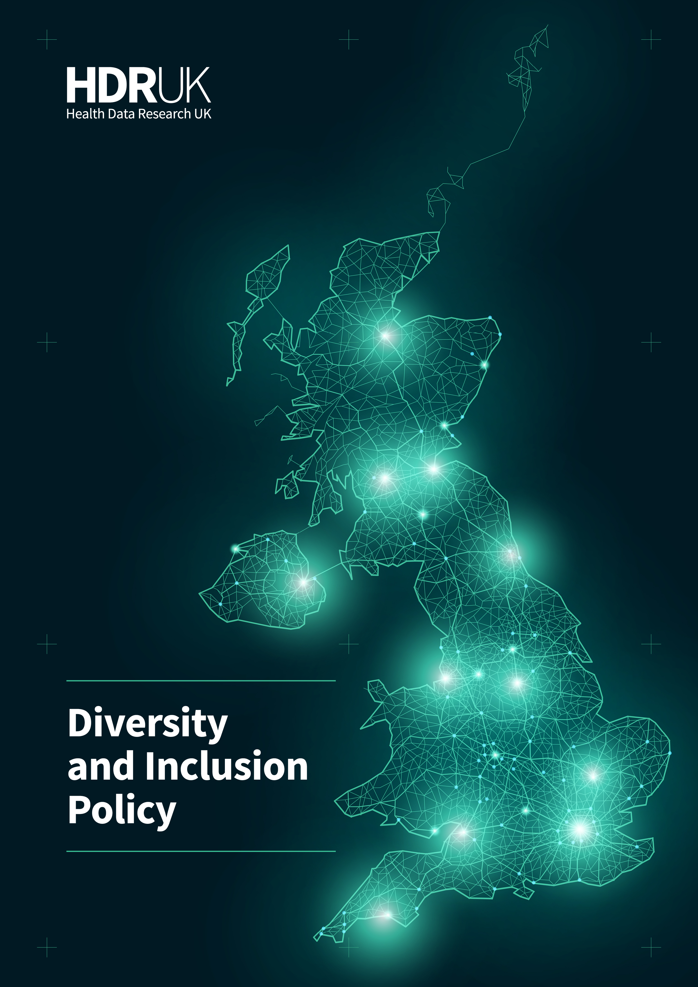

Foreword
We want the UK to be the place to do the most impactful health data research and innovation. Embracing diversity is a key way in which we will achieve this. Reaching our potential in making discoveries that improve people’s lives using health data requires an inclusive community, a diverse workforce, and data representing all segments of society, diseases and conditions. We will learn through these differences.
We are learning from research on the relationship between ethnicity and the COVID-19 pandemic, as well as events relating to the Black Lives Matter movement, to better serve the whole population of the UK.
We want to listen to a diverse range of perspectives so that we understand opportunities and concerns seen by patients, public and practitioners to enable us to develop approaches that build trust. We encourage working with a broad community of people as health data scientists, valuing the use of data for discoveries by researchers and innovators in industry, the NHS, charities, government and academia. We need the best talent to achieve our mission, grown from all areas of health data science, geographies, and expertise.
We don’t see a compromise between quality and diversity and, in fact, we are pursuing higher quality through greater diversity. COVID-19 has shown this clearly. The breadth of skills and data needed from different sources across the country to respond to the wide range of direct and indirect implications from the disease makes the point. We have also seen how the response to COVID-19 has resulted in new ways of working and these are helping to create a more accessible and inclusive environment for different groups of people. We will learn from this.
Our values of transparency, optimism, respect, courage and humility inspire the behaviours that help each of us to encourage diversity and be inclusive. No individual, organisation or sector has all the answers and we need to create an environment where we can work well together and as a result achieve more. This Diversity and Inclusion Policy is a start, and it will evolve as we learn. I encourage you to adopt the practices in here and for you to encourage me, yourselves and each other to achieve more through greater diversity and inclusion.
Caroline Cake
Chief Executive Officer, Health Data Research UK

Policy statement

HDR UK’s mission is to unite the UK’s health data to make discoveries that improve people’s lives.
We know we can do more and deliver better outcomes by bringing together a wide range of people, skills, ideas, opinions, beliefs and experiences. This is how we define diversity and know that it strengthens each part of HDR UK. It helps us to be stronger and better – by generating new insights and innovations from different perspectives, diverse data, different skills, and different populations.
We embrace diversity and all the ways we are different – visible and non-visible. We commit to providing equal opportunities to ensure no individual or group is treated differently or less favourably. We will create an environment where people with diverse backgrounds, insights and experiences can work together openly and with respect. By working in this way, we embody our values of transparency, optimism, respect, courage and humility and create an environment that is inspiring, collaborative and delivering at pace and scale.

As an institute we are committed to being fair, inclusive and facilitate diversity in all aspects of our work. This includes the people that make up our workforce, represent us and benefit from the work we support; the perspectives we seek to guide the work we do; the training that the next generation of data scientists need to deliver health data research to make discoveries that improve people’s lives; and the data we unite across the UK’s varied populations.
A lack of diversity in any of these areas will hold us back from bringing together the sharpest scientific minds, providing access to rich health data that represents the UK’s entire population, and better understanding diseases to prevent, treat and cure them.

Objectives – What does this look like in practice?
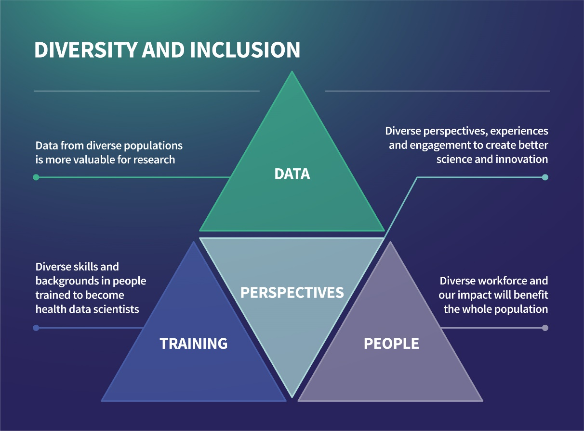
Data: To support research based on diverse health data ranging from electronic health records generated through routine healthcare in primary, secondary and tertiary healthcare and social care, to carefully-curated research-ready cohort data.
People: To be an inclusive environment supporting all people – regardless of gender, disability, sexual orientation, age, religion, race, maternity/parental status and socioeconomic background – whether they are employees, members, research participants, those being trained as health data scientists or benefitting from the research we support.
Training: To equip the workforce with the training it needs to develop the diverse skills that are required to prevent, treat and cure disease, from bioinformatics to statistics, to computer programming or coding.
Perspectives: To bring diverse perspectives into the heart of our work – including patients, practitioners, the public, industry, the NHS, policy makers and academia – to create better science and innovation.

Policy interventions – Our priorities for 2020
In 2020, our policy focuses on two key areas:
- Proactively championing a significant increase in diversity of datasets and show why this is important in achieving our mission
- Putting in place interventions to enhance diversity and inclusion of people across the HDR UK community.

Diversity of datasets
Events in the first quarter of 2020 have demonstrated deficits in the diversity of data available for research and innovation. Examples include the absence of data from social care, particularly for people living in care homes, and the gaps in data required to support vital research on the impact of COVID-19 on UK black and Asian communities and people from minority ethnic groups.
The world’s health research and innovation community has struggled to quickly and categorically determine whether ethnicity plays a role in risk of contracting COVID-19, its severity and why. For example, we have not been able to provide an unambiguous answer to the question of whether or why black people in the UK are more susceptible to contracting COVID-19, and more likely to experience severe symptoms and outcomes. This is a result of a lack of ethnic representation in many health datasets, unequal access for people to join research cohorts and a lack of robustness in how information about ethnicity is recorded in health records and other health datasets. This reduces the effectiveness of health data science to understand diseases such as COVID-19 and their impact on the diverse populations in the UK. It also has an impact on the effectiveness of tools and technologies developed in health data science (e.g. polygenic risk scores and disease risk calculators), which are only as good as the diversity of datasets (in terms of the range of patients and public from whom data is derived) used to develop them.
COVID-19 has taught us that ethnicity matters when it comes to health and healthcare, and that we are not yet equipped with the right datasets we need. The Black Lives Matter movement has taught us that we all have we a responsibility to take proactive steps to ensure that health data research in the UK benefits everyone regardless of ethnicity.
We are responding to this to ensure that the research and innovation that is enabled by health data has the capability to serve the whole population of the UK, by proactively championing an increase in diversity of health datasets.
We will ensure that the datasets discoverable on the Health Data Research Innovation Gateway reflect the diversity of the UK population. We will work with health data custodians that manage diverse data and encourage them to join the UK Health Data Research Alliance.

Diversity and inclusion of people in the HDR UK community
As a distributed institute across all parts of the UK, we will create an inclusive environment that welcomes and supports all people. We recognise that we have gaps, that we need to learn and, in some parts of our institute, we are not actively supporting or championing diversity. We will address these shortcomings in the following ways.
Staff recruitment, retention and engagement
We will review the way that we recruit, retain and support people at HDR UK and ensure our processes are fair, open and champion diversity. We want to attract skilled and high-performing people and will work to reduce or eliminate any barriers that relate to diversity and inclusion. We will give ourselves the best chance of eliminating bias in recruitment by:
- Increasing quality of applicant and interviewer pools for posts in our central team, by avoiding those that lack diversity (e.g. single-gender, single-ethnicity), by using the full breadth of HDR UK’s federated network, making use of video conference facilities for interviewers and interviewees, and otherwise extending recruitment deadlines.
- Using competency-based application forms to avoid bias.
- Running job descriptions/adverts through a gender bias screen.
- Providing unconscious bias training for everyone who is involved in recruitment in our central team.
Events
We will use our events to celebrate diversity and inclusivity, ensuring they are open and accessible, by:
- Videoconference-enabling events, so they are accessible to a wider audience.
- Driving-up quality of discussions by avoiding panels and speaker line-ups that lack diversity (e.g. single-gender, single-ethnicity) at our events
- Using an ‘inclusive calendar’ when planning our events to avoid hosting meetings during school holidays (to support working parents) and major religious holidays etc.
- Considering whether out-of-hours working, such as ‘working dinners’, are inclusive for the cross-section of attendees, on an event-by-event basis, and considering alternative arrangements, such as networking lunches
- Providing an accessibility info sheet for events organised by our central team

Communications and engagement
We will use our full range of channels for communications and engagement to celebrate the diversity in our community, to highlight our shortcomings and how we intend to overcome these. We will support internationally recognised days that are relevant to diversity by showcasing the work of members of our community.
We will engage with and involve people from diverse communities to provide input and contributions and ensure our work benefits patients and the public of diverse backgrounds.
Our website and social media platforms are important channels of communication with our community and the public. We will ensure that the people and settings depicted in the images we use, and those whose work is highlighted, convey a message on diversity and inclusion.
We are also increasing our digital accessibility by using more public-friendly language where possible, appropriate font size, document format, colour palette and increasing ease of website navigability.

Development of this policy
This policy was published and enacted in June 2020. It is reviewed every six months. We provide regular updates on progress against the priorities set out in this policy on the designated webpage: https://www.hdruk.ac.uk/diversity-and-inclusion-policy/.
If you would like to provide feedback or suggestions on the policy, please contact us by email at feedback@hdruk.ac.uk or through our anonymous feedback form.

An electronic health record is the collection of health data for a patient, collected during the course of routine health and social care. It is electronically-stored in a digital format – by hospitals, GPs etc. They may include a range of data, including demographics, medical history, medication and allergies, immunisation status, laboratory test results, radiology images, vital signs, personal statistics like age and weight, etc. They are an important source of data for health research.
Cohort data is information collected from a specific group of people over the course of their lives. Those who set up cohorts, follow the health and well-being of the volunteer participants and provide health information, which does not identify them, to approved researchers to conduct health research. Examples of cohorts include UKBiobank (group of people from the general population); and Genes & Health (one of the world’s largest community-based genetics studies, aiming to improve health among people of Pakistani and Bangladeshi heritage by analysing the genes and health of 100,000 local people).
A polygenic risk score tells you how a person's chances of developing a disease or health condition compares to others with a different genetic make-up.

