Diversity and inclusion policy progress report

January 2021 update

We regularly report on progress we make on our diversity and inclusion aims. We are steadily moving our way towards a more positive environment, and in doing so, stitching inclusive practices and systems into the fabric of HDR UK to embed lasting change. In the first three months since publishing our first diversity and policy, we made 25 interventions to improve diversity and inclusion:

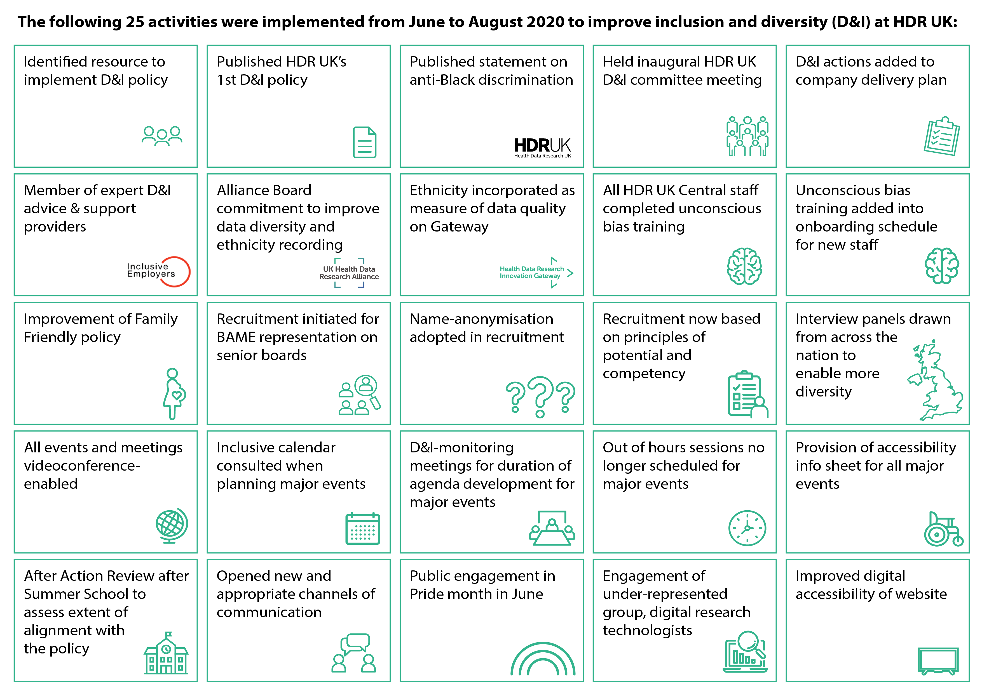

Highlights of activities that took place in the following 3 months include:

- Key activities to enact our Statement on Anti-Black Racial Discrimination, which is also supported by the UK Health Data Research Alliance:
  - We developed and launched the HDR UK Black Internship Programme, as part of a national cross-sectoral initiative, the 10,000 Black Interns Scheme. We received 159 applications for 44 places, which will be hosted by 22 organisations including those that comprise our National Priorities, UK Health Data Research Alliance and other partners. We will be welcoming the successful candidates for their internships in summer 2021.
  - Convened an advisory group to co-develop the Black Internship programme which meets regularly and comprises: Martin Levermore, Beverly Lindsay, #BlackInDataWeek co-founder Ruth Agbakoba and Louise Toner.
  - As part of Black History Month, five researchers for the UK’s health data research community wrote blogs to share their perspectives, journeys and health data research: Mwenza Blell, Martin Levermore, Gwenetta Curry, Adepeju Oshisanya and Musa Abdulkareem.
  - Supported #BlackInDataWeek (16-21 November 2020) through publicising through our networks and encouraging the HDR UK community to participate.
- We trialled the use of a new platform, BeApplied, for HDR UK to manage applications to the Black Internship Scheme, which blinded and randomised the scoring process. This was a great success and we will use it in the future for other purposes to work around unconscious bias.
- We set up a Diversity and Inclusion Committee which meets quarterly to review progress against the ambitions set out in our policy, and plan new initiatives and changes. It is a combination of independent advisors, those with the authority to enact change across the organisation, a professional inclusion and diversity consultant, as well as a rotating seat for a guest from the HDR UK community at each meeting, to ensure we regularly bring in a range of perspectives.
- Read more about our progress and ambitions through these blogs around the four core elements of our diversity and inclusion policy – people, data, skills and perspectives. These pieces were published as part of a programme of activities we put together to mark National Inclusion Week (September 28th- October 4th 2020).
We will continue to introduce more inclusive and equitable systems and processes into HDR UK, to move ever closer to an environment where diversity is fully embraced. We strive for a more equitable community and to remove barriers to achieving the HDR UK vision that every health and care interaction and research endeavour will be enhanced by access to large scale data and advanced analytics.

